ASSIGNMENT – 17.2

NAME : BHAWWANA SHRE
HALLTICKECT NO : 2403A52311
BATCH NUMBER : 01
COURSE CODE : 24CS002PC215
PROGRAM NAME : B.TECH
YEAR/SEM : 2ND AND 3RD

^{TASK 1 :}
Clean raw social media posts dataset.
^{PROMPT:}
Use AI to clean a social media posts dataset:
- Remove stopwords, punctuation, and special symbols from text.
- Fill missing values in likes/shares.
- Convert timestamp to datetime and extract hour, weekday.
- Remove spam and duplicate posts.

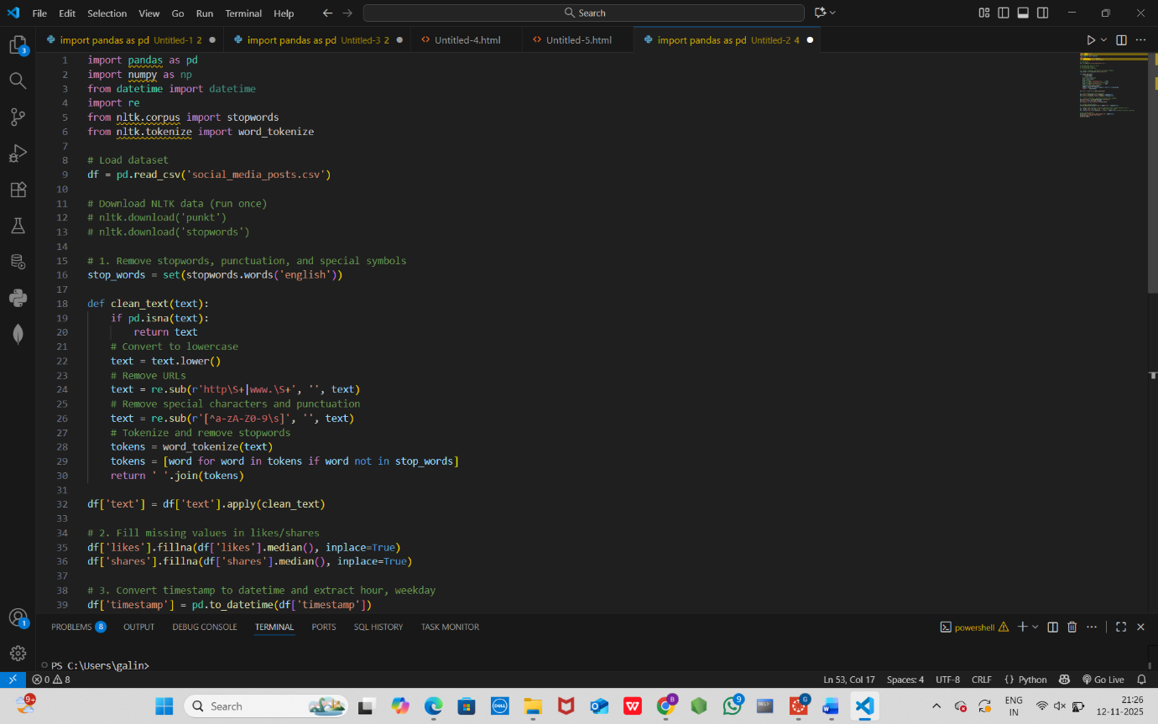
CODE :

OUTPUT :
cleaned dataset ready for sentiment/engagement analysis.

TASK 2 :
Preprocess a stock market dataset.
PROMPT :
Use AI to preprocess a stock market dataset:
- Handle missing values in closing_price and volume.
- Create 1-day and 7-day lag return features.
- Log-scale the volume column.
- Detect outliers in closing_price using IQR.
Output: cleaned time-series dataset ready for forecasting.

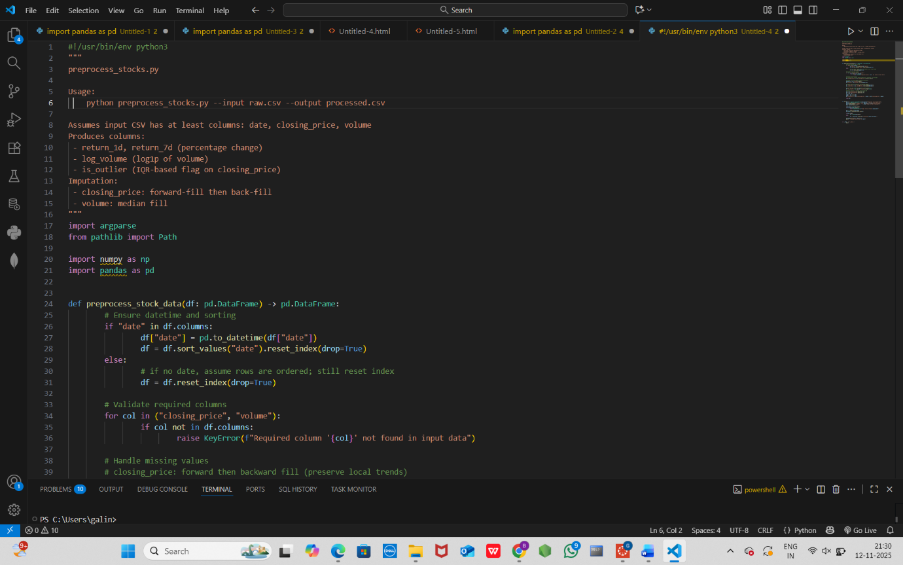
CODE :

OUTPUT :
cleaned time-series dataset ready for forecasting.

TASK 3 :
Clean and preprocess IoT temperature and humidity logs.

PROMPT :
Use AI to preprocess IoT sensor data:
- Forward fill missing values.
- Remove sensor drift with rolling mean.
- Standard scale temperature and humidity.
- Encode sensor IDs.

CODE :
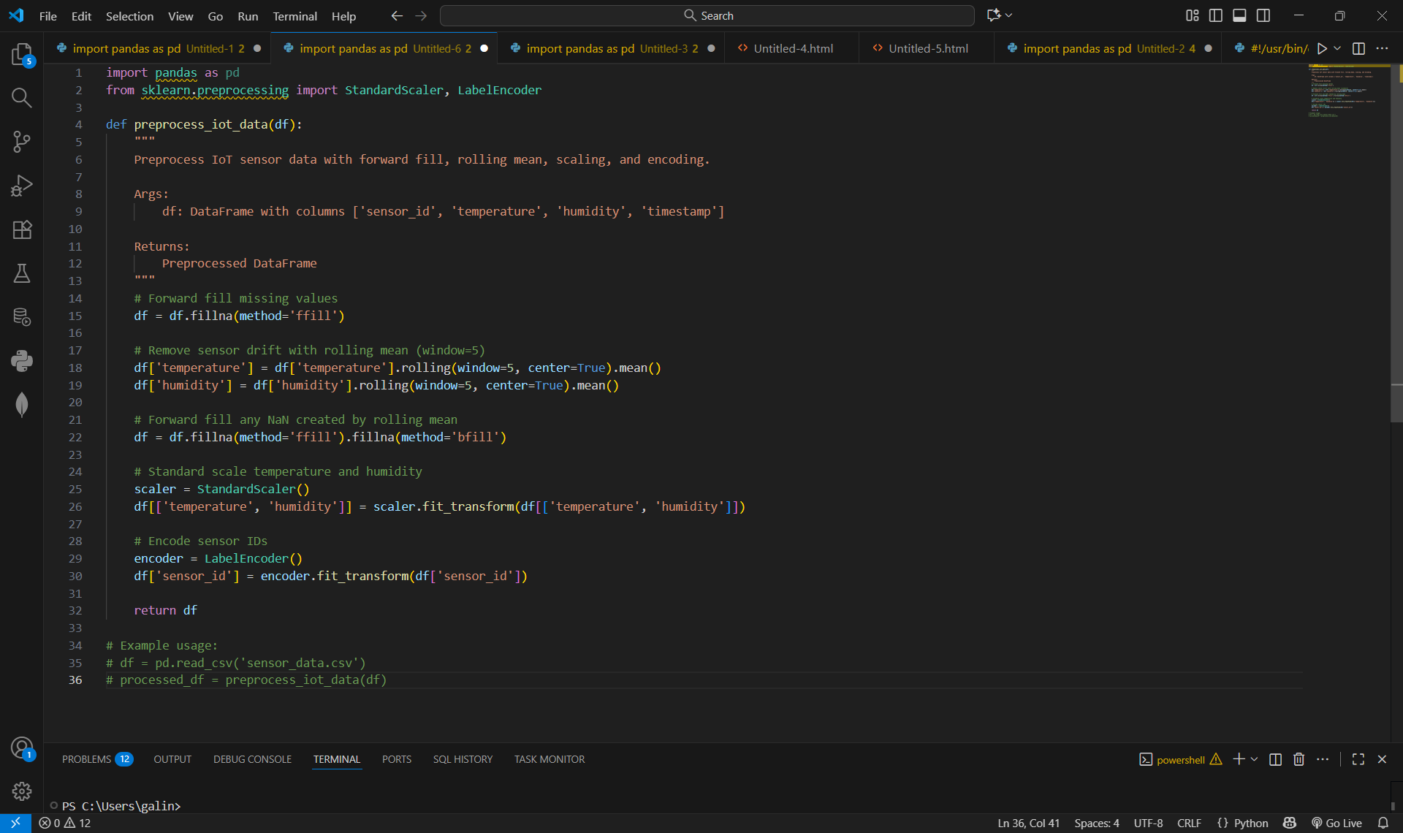

OUTPUT:
- structured dataset ready for anomaly detection.

TASK 4 :
A streaming platform wants to analyze customer reviews.

PROMPT :
Use AI to clean and preprocess movie reviews:
- Convert text to lowercase and remove HTML tags.
- Tokenize and encode reviews using TF-IDF or embeddings.
Output: processed dataset ready for sentiment analysis.

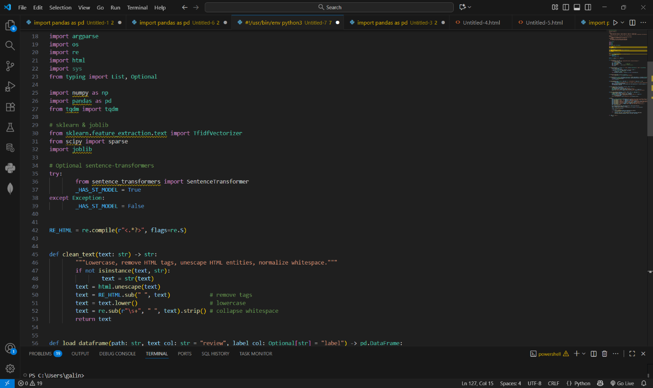
CODE :

OUTPUT :
processed dataset ready for sentiment analysis.

